Optics And Endoscopy

- Define ‘total internal reflection (TIR)’ and outline the conditions under which it occurs.
- Define ‘critical angle’ and calculate this for a range of different conditions.
- Explain how a fiber-optic cable works.
- Discuss the role of fiber-optic cables in endoscopy.
- Define ’acceptance angle’ and ‘numerical aperture’ and calculate these for a range of different conditions.
- Discuss the significance of the above with regard to fiber-optics in endoscopes.

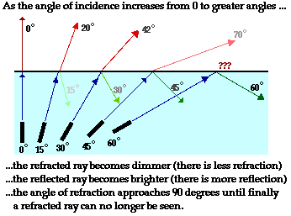 | 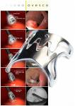 | 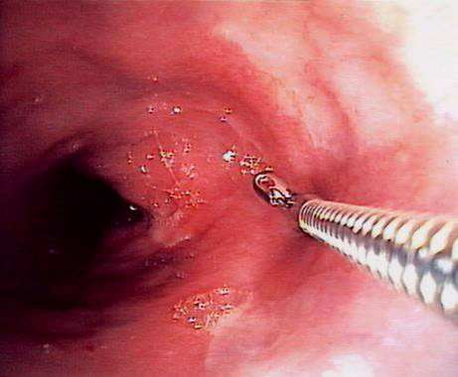 | 